**DLCV HW1**

**資工所碩一 R07922043**

**Problem1.**

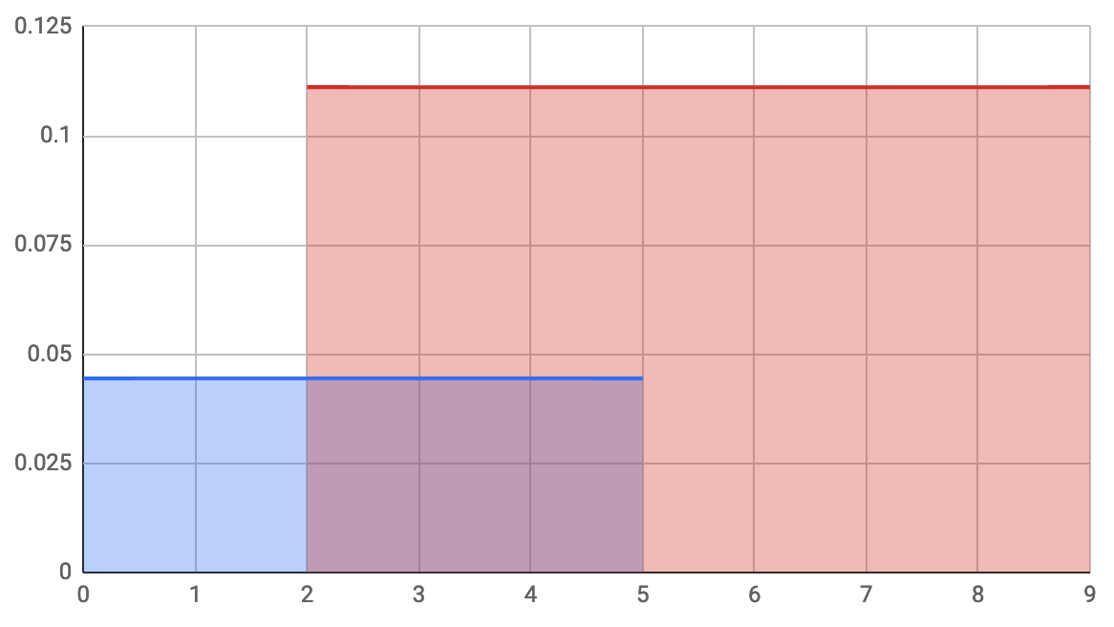

Decision region R1 : $0≤X≤2$, Decision region R2 : $2<X≤9$

$$P_{e}=\int_{2}^{5}{P(X|ω_{1})×P(ω_{1})}dx=3×\frac{1}{5}×\frac{2}{9}=\frac{2}{15}$$

**Problem2.**

1. Result :

|  |  |  |  |  |
| --- | --- | --- | --- | --- |
| Mean face | Eigenface 1 | Eigenface 2 | igenface 3 | igenface 4 |
|  |  |  |  |  |

1. Result :

|  |  |  |  |
| --- | --- | --- | --- |
| n=3 | n=45 | n=140 | n=229 |
|  |  |  |  |

1. MSE value:

|  |  |  |  |
| --- | --- | --- | --- |
| n=3 | n=45 | n=140 | n=229 |
| 1007.256928172 | 261.120280518 | 18.31713151151 | 0.1096315950653 |

1. Result: average accuracy in 3-fold cross validation

|  |  |  |  |
| --- | --- | --- | --- |
|  | n = 3 | n = 45 | n = 140 |
| k = 1 | 0.7291 | 0.9291 | 0.9375 |
| k = 3 | 0.6166 | 0.8375 | 0.8333 |
| k = 5 | 0.5750 | 0.7833 | 0.7541 |

1. 根據上第四小題的結果，因為(k=1,n=140)的正確率最高，所以使用(k=1,n=140)。

正確率為0.94375

**Problem3.**

1. Result :

|  |  |  |  |  |
| --- | --- | --- | --- | --- |
|  | Category1 | Category2 | Category3 | Category4 |
| Grid1 |  |  |  |  |
| Grid2 |  |  |  |  |
| Grid3 |  |  |  |  |

切成grid之後可以利用圖片的顏色等特性，可以不用看完整的圖片就有可能對圖片進行分類。

1. Result :

兩張圖的x,y,z軸scale不一樣，因此看起來沒有對齊。

|  |  |
| --- | --- |
| 6 category points | 6 category center points |
|  |  |

1. Result :

|  |  |
| --- | --- |
| Category 1 | Category 2 |
|  |  |
| Category 3 | Category 4 |
|  |  |

1. Result :

正確率：0.67

**Problem4.**

1. R
2. Gaussian filter有模糊的效果。

|  |  |
| --- | --- |
| 原圖 | After Gaussian filter |
|  |  |

1. D

|  |  |  |
| --- | --- | --- |
| 原圖 | Ix filter | Ix filter |
|  |  |  |